**Computer Networks**

**Problem-solving session 9-1**

**Configure Initial Router Settings**

**Objectives**

**Part 1:** Verify the Default Router Configuration

**Part 2:** Configure and Verify the Initial Router Configuration

**Part 3:** Save the Running Configuration File

**Background**

In this activity, you will perform basic router configuration tasks. You will secure access to the CLI and console port using encrypted and plain-text passwords. You will also configure messages for users who are logging into the router. These banners warn unauthorized users that access is prohibited. Finally, you will verify and save your running configuration.

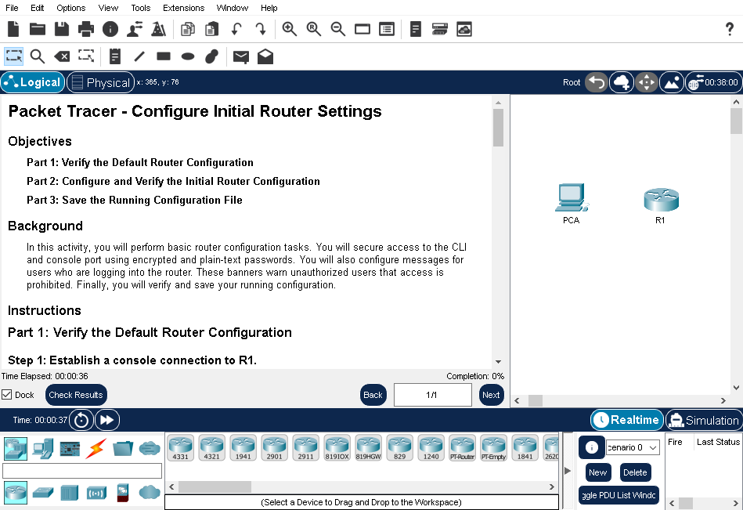

**Part 1: Verify the Default Router Configuration**

**Step 1:** Establish a console connection to R1.

a. Choose a **Console** cable from the available connections.

b. Click **PCA** and select **RS 232**.

c. Click **R1** and select **Console**.

d. Click **PCA** > **Desktop** tab > **Terminal**.

e. Click **OK** and press **ENTER**. You are now able to configure **R1**.

**Step 2:** Enter privileged mode and examine the current configuration.

You can access all the router commands from privileged EXEC mode. However, because many of the privileged commands configure operating parameters, privileged access should be password-protected to prevent unauthorized use.

a. Enter privileged EXEC mode by entering the **enable** command.

Router> enable

Router#

Notice that the prompt changed in the configuration to reflect privileged EXEC mode.

b. Enter the **show running-config** command.

Router# show running-config

What is the router’s hostname?

______________________Router_________________________

How many Fast Ethernet interfaces does the Router have?

___________________________4_______________________________________________

How many Gigabit Ethernet interfaces does the Router have?

_______________________________2___________________________________________

How many Serial interfaces does the router have?

_____________________2_____________________________________________________

What is the range of values shown for the vty lines?

_________________0 - 4___________________________________

c. Display the current contents of NVRAM.

Router# show startup-config

startup-config is not present

Why does the router respond with the startup-config is not present message?

_____Because we havent yet yet saved the ocnfiguration file to the NVRAM.

**Part 2: Configure and Verify the Initial Router Configuration**

To configure parameters on a router, you may be required to move between various configuration modes. Notice how the prompt changes as you navigate through the IOS configuration modes.

**Step 1:** Configure the initial settings on R1.

Note: If you have difficulty remembering the commands, refer to the content for this topic. The commands are the same as you configured on a switch.

a. Configure **R1** as the hostname.

b. Configure Message of the day text: **Unauthorized access is strictly prohibited**.

c. Encrypt all plain text passwords.

Use the following passwords:

1) Privileged EXEC, unencrypted: **cisco**

2) Privileged EXEC, encrypted: **itsasecret**

3) Console: **letmein**

**Step 2:** Verify the initial settings on R1.

a. Verify the initial settings by viewing the configuration for R1. What command do you use?

___________________show running-config____________

b. Exit the current console session until you see the following message:

R1 con0 is now available

Press RETURN to get started.

c. Press **ENTER**; you should see the following message:

Unauthorized access is strictly prohibited.

User Access Verification

Password:

Why should every router have a message-of-the-day (MOTD) banner?

___________________Every router needs a notice to tell people without permission that they can't use it. Message of the Day (MOTD) Banners are good for giving messages to network staff too, like telling them about planned shutdowns or who to ask for access.___________

If you are not prompted for a password before reaching the user EXEC prompt, what console line command did you forget to configure?

_________________R1(config-line)#login_______________________________

d. Enter the passwords necessary to return to privileged EXEC mode.

Why would the enable secret password allow access to the privileged EXEC mode and the enable password no longer be valid?

_______________If we set up both an enable password and an enable secret password on a router, you need to use the enable secret password to access privileged EXEC mode. This is because the enable secret password takes priority over the enable password.______________________________________________________

If you configure any more passwords on the router, are they displayed in the configuration file as plain text or in encrypted form? Explain.

________________The service password-encryption command encrypts all the passwords.________________________________

**Part 3: Save the Running Configuration File**

**Step 1:** Save the configuration file to NVRAM.

a. You have configured the initial settings for **R1**. Now back up the running configuration file to NVRAM to ensure that the changes made are not lost if the system is rebooted or loses power.

What command did you enter to save the configuration to NVRAM?

____copy running-config startup-config___________________________________________

What is the shortest, unambiguous version of this command?

___________cop r st___________________________________________________

Which command displays the contents of the NVRAM?

______________show startup-configuration or show start__________________

d. Verify that all parameters configured are recorded. If not, analyze the output and determine which commands were not executed or were entered incorrectly. You can also click **Check Results** in the instruction window.

**Step 2**: Optional: Save the startup configuration file to flash.

Although you will be learning more about managing the flash storage in a router in later chapters, you may be interested to know that, as an added backup procedure, you can save your startup configuration file to flash. By default, the router still loads the startup configuration from NVRAM, but if NVRAM becomes corrupt, you can restore the startup configuration by copying it over from flash.

Complete the following steps to save the startup configuration to flash.

a. Examine the contents of flash using the **show flash** command:

R1# show flash

How many files are currently stored in flash?

________________3__________________________________________________________

Which of these files would you guess is the IOS image?

_______________c1900-universalk9-mz.SPA.151-4.M4.bin_____________________

Why do you think this file is the IOS image?

______________the .bin at the end of the file name._________________________

b. Save the startup configuration file to flash using the following commands:

R1# copy startup-config flash

Destination filename [startup-config]

The router prompts you to store the file in flash using the name in brackets. If the answer is yes, then press **ENTER**; if not, type an appropriate name and press **ENTER**.

c. Use the **show flash** command to verify the startup configuration file is now stored in flash.

**Here is my result:**

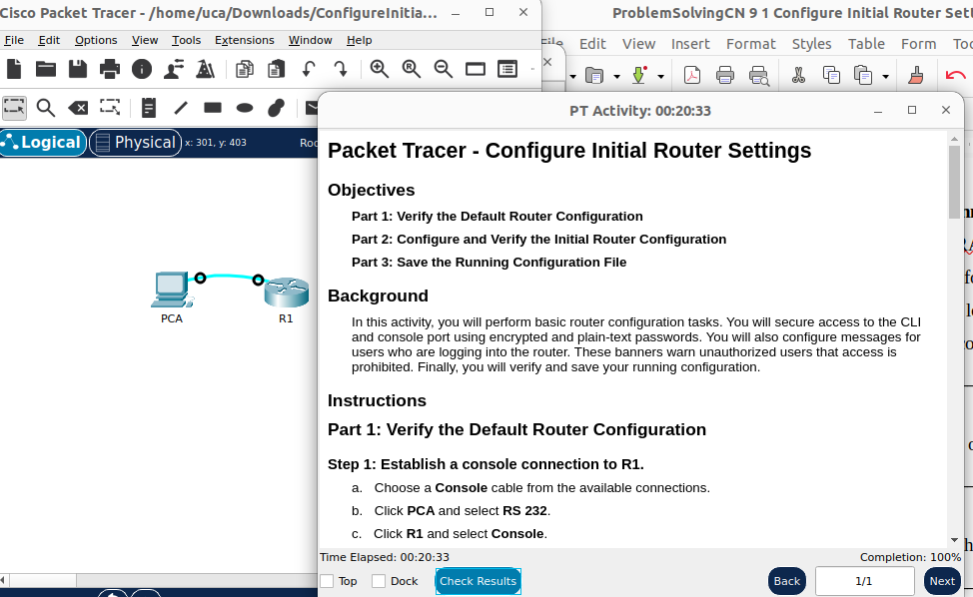

Completion must be 100 %. Perhaps you will need to start the **service password-encryption** command at the end to have this percentage.

